SQL - JOINS

Inner Join

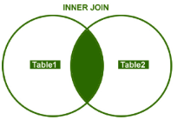

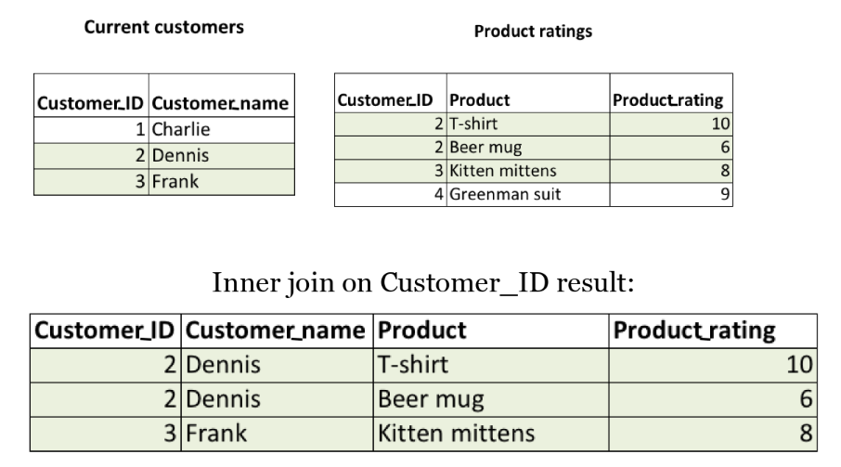

Keeps information which is in BOTH tables.

Left Join

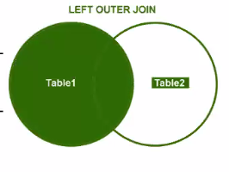

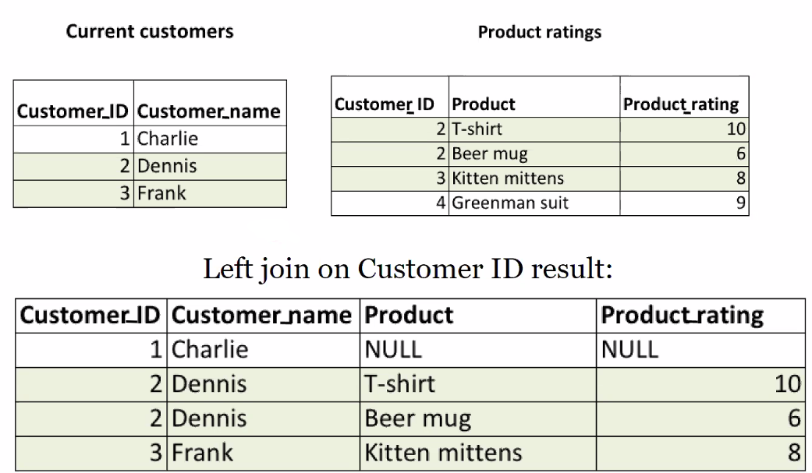

Keeps information which is in the LEFT table, even if there is no information in the right table for that entry. Hence why we have null values.

Right Join

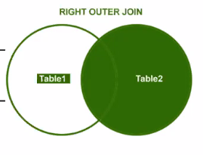

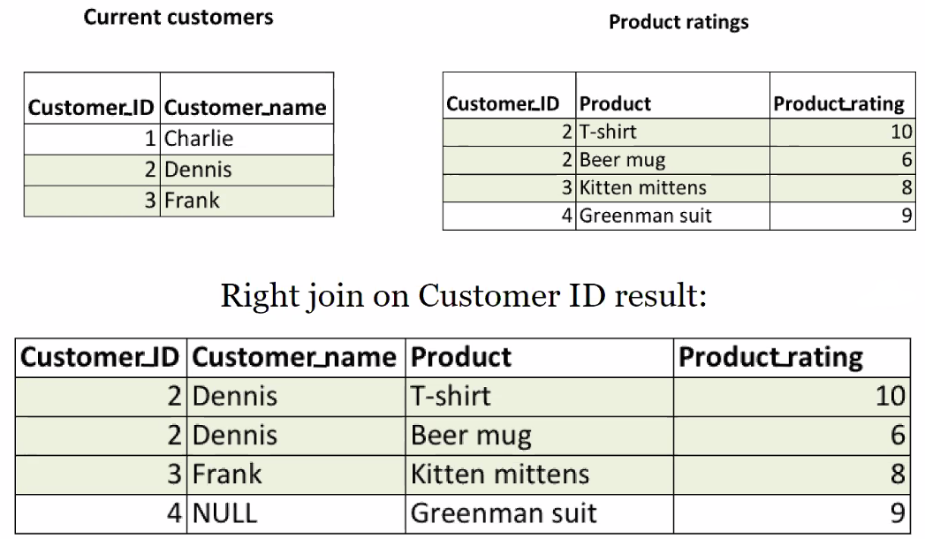

Keeps information which is in the RIGHT table, even if there is no information in the left table for that entry. Hence why we have null values.

Outer Join (Full Outer Join)

Combines all information from BOTH tables. Hence why we have null values.